Automating E-Government Services with Artificial Intelligence

In this project we are developing online application where user can apply for various certificates such as Birth, death certificates, income or community certificates. We are employing artificial intelligence technique where application will automatically identify type of certificate and then birth and death certificate will be send to hospital authorities and community or income certificate will be forward to revenue department.

Once hospital and revenue validated user details then they will submit approval status to admin and then admin will issue certificate to user. User can download certificate by using OTP sent to their email. While sign up user has to enter valid email id to receive all OTPS.

To implement this project we have designed following modules

New User Sign up: user will enter sign up details to register with the application

User Login: after sign up user can login to application and then can apply for certificates, view and download certificate and can view all events or schemes publish by admin on behalf of government

Hospital Login: hospital can login to system using username and password as ‘hospital and hospital’ and then view list of certificate request and then either accept or reject certificate request based on genuine of fake submitted details

Revenue Department Login: department can login to system using username and password as ‘revenue and revenue’ and then view and approve income or community certificate request

Admin: admin can login to system using username and password as ‘admin and admin’. After login can view list of approved certificate and then upload all certificates to all approved users. Can publish schemes on behalf of government.

To run project install Python3.7 and then install all packages given in requirement.txt file and then install MYSQL database and then copy content from ‘database.txt’ file and paste in MYSQL to create database

SCREEN SHOTS

To run project double click on ‘run.bat’ file to get below screen

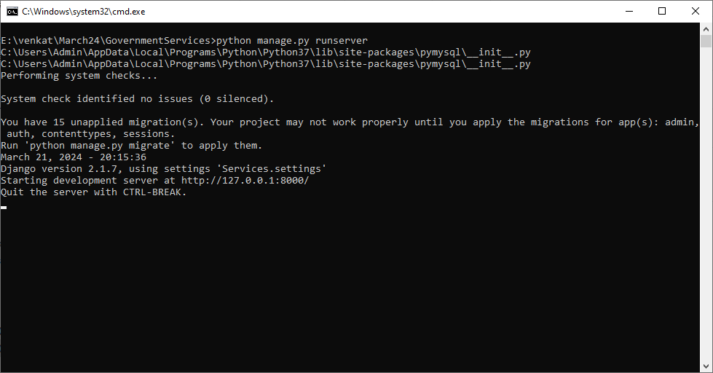

In above screen python server started and now open browser and enter URL as <http://127.0.0.1:8000/index.html> and press enter key to get below page

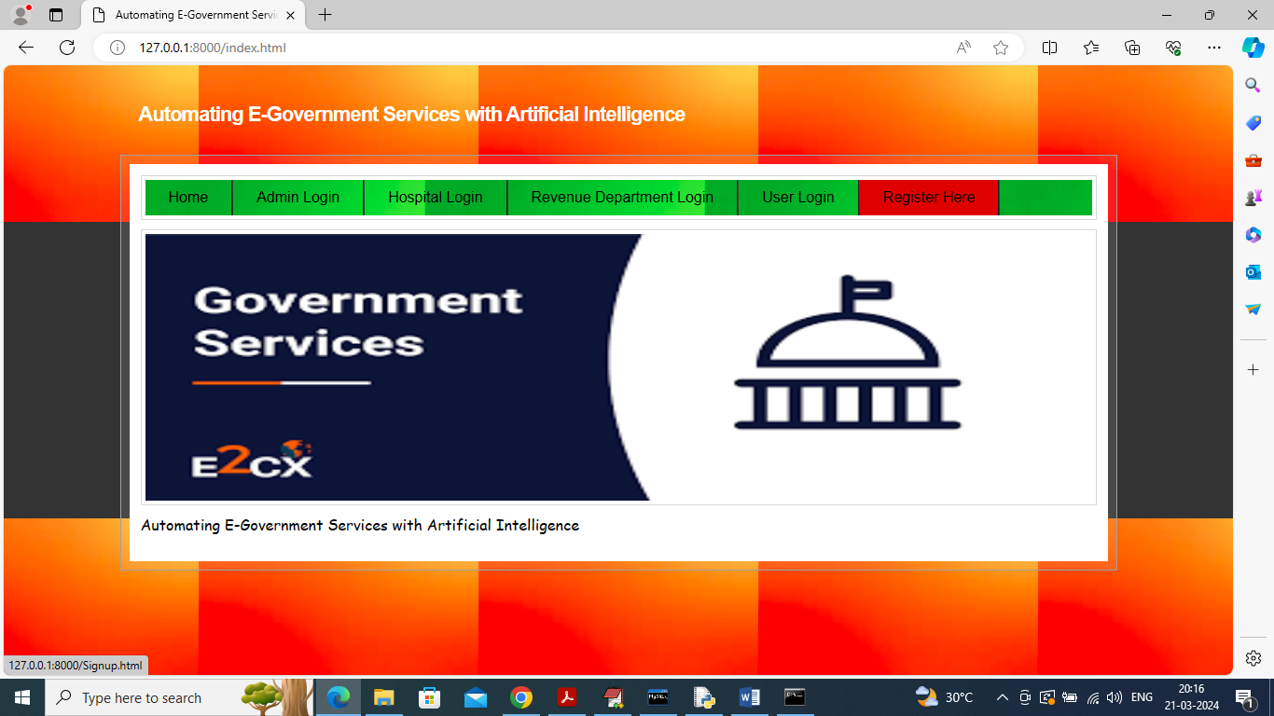

In above screen click on ‘Register Here’ login to get below sign up page

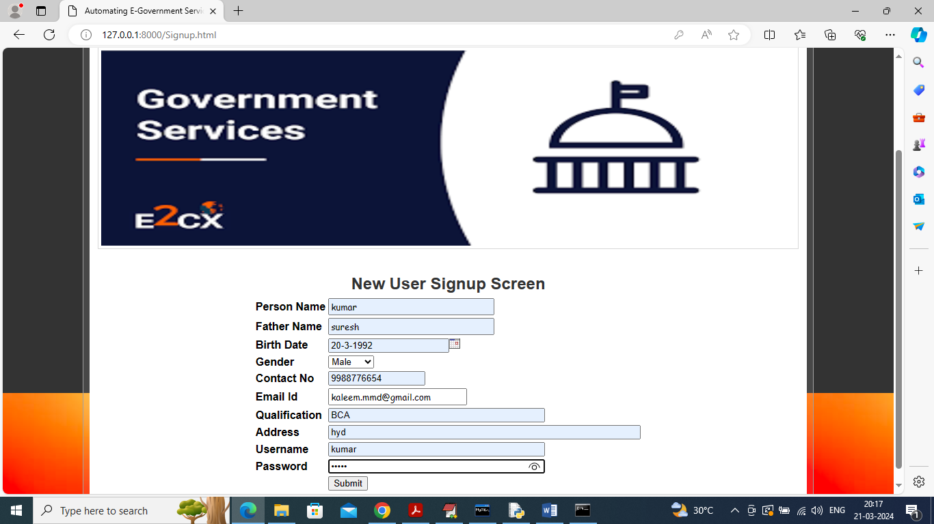

In above screen user is entering sign up details and then click on ‘Submit’ button to saved user details and get below page and give valid email id to receive OTP

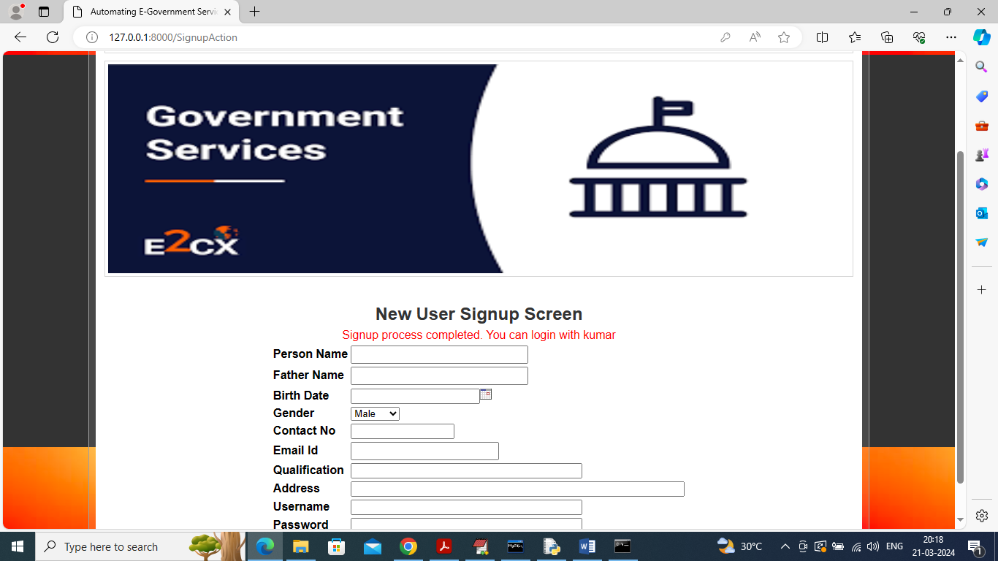

In above screen user sign up process completed and now click on ‘User Login’ link to submit certificate request

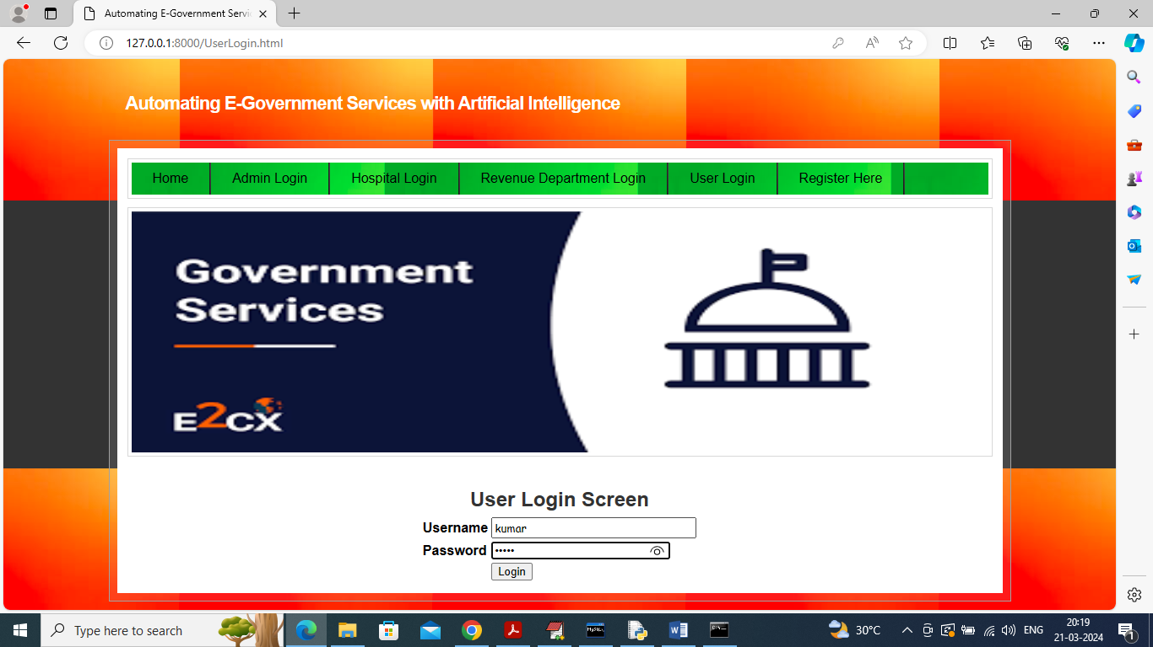

In above screen user is login and after login will get below page

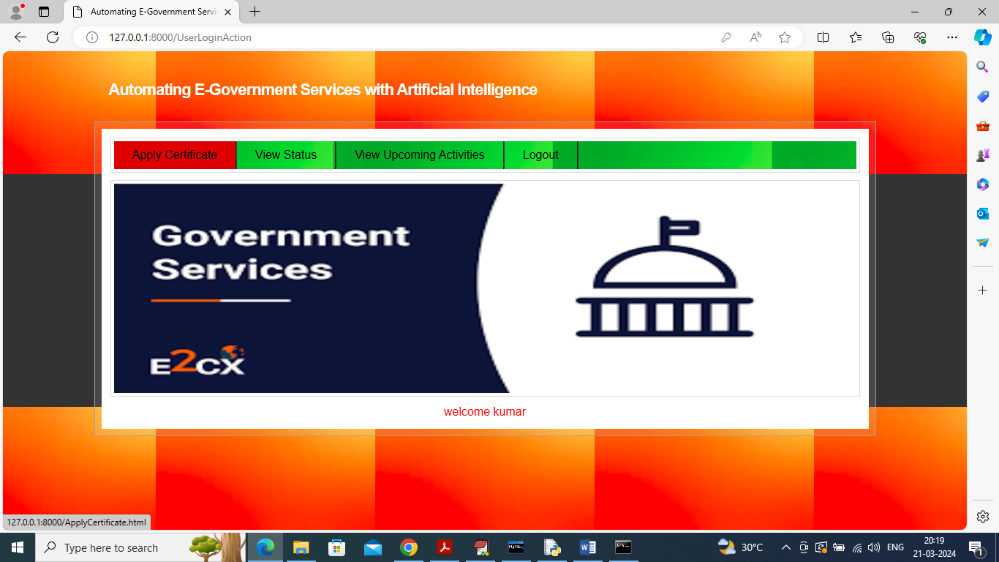

In above screen click on ‘Apply Certificate’ link to submit certificate request and get below page

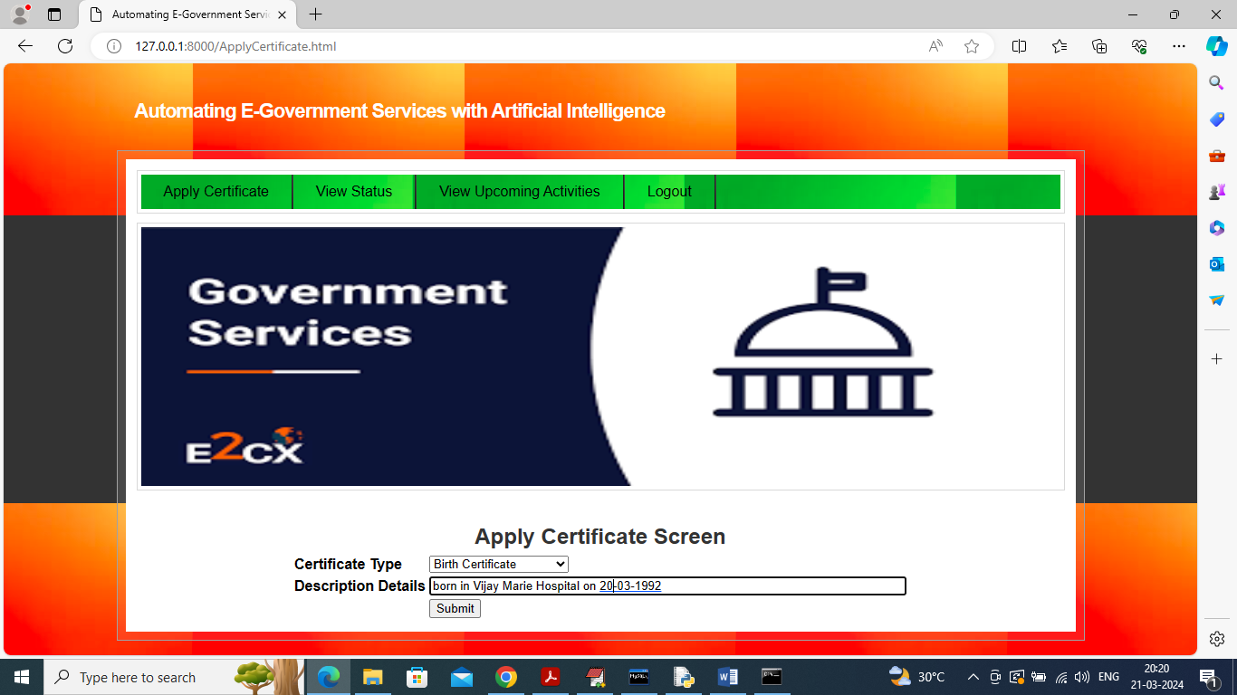

In above screen user will enter some details and then press button to submit request to hospital or revenue department and get below page

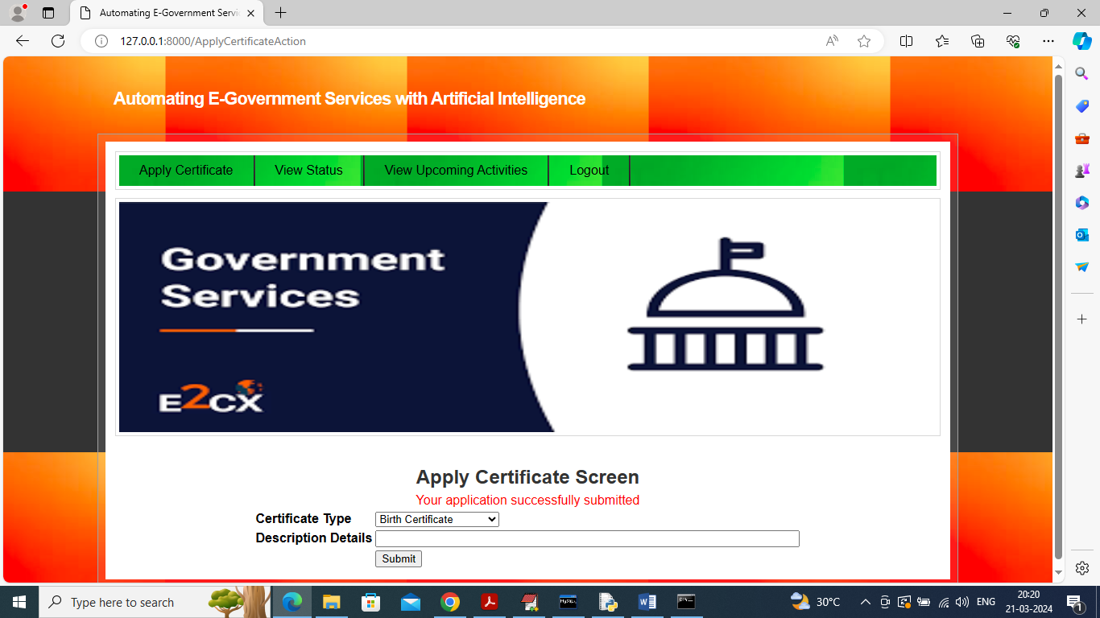

In above screen certificate request successfully submitted and similarly single user can create all 4 types of certificate request. Now will add income certificate which will go to revenue department

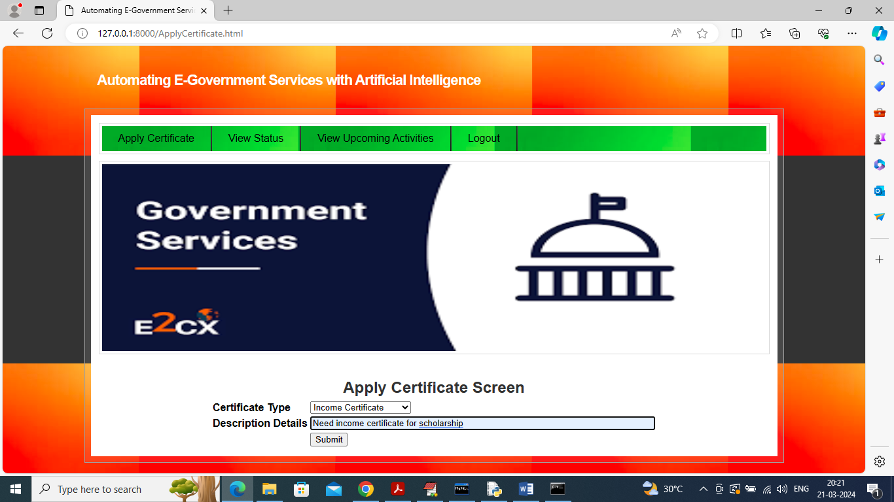

In above screen submitted request for income certificate and hospital will get birth and death certificate request and income and community request goes to revenue department. Now logout and login as ‘Hospital’ to approve or reject request

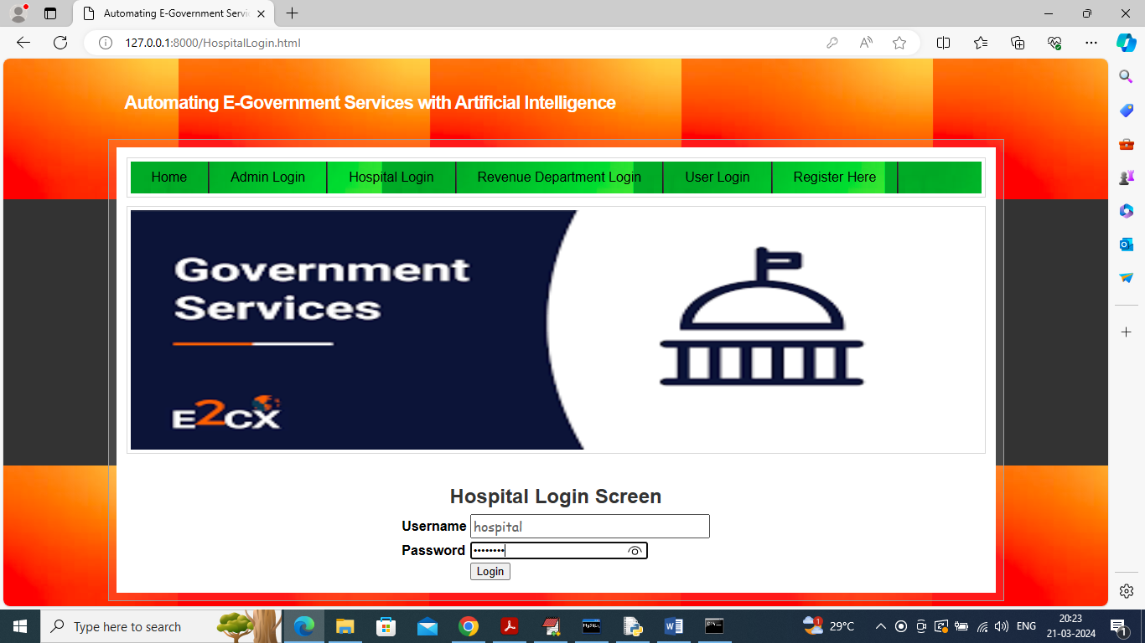

In above screen hospital is login and after login will get below page

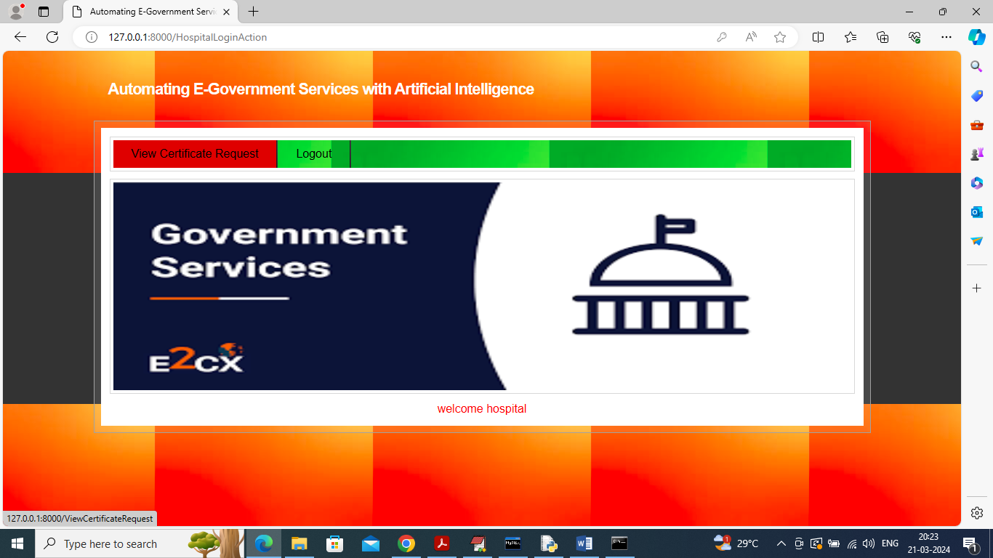

In above screen hospital can click on ‘View Certificate Request’ link to get all details of user

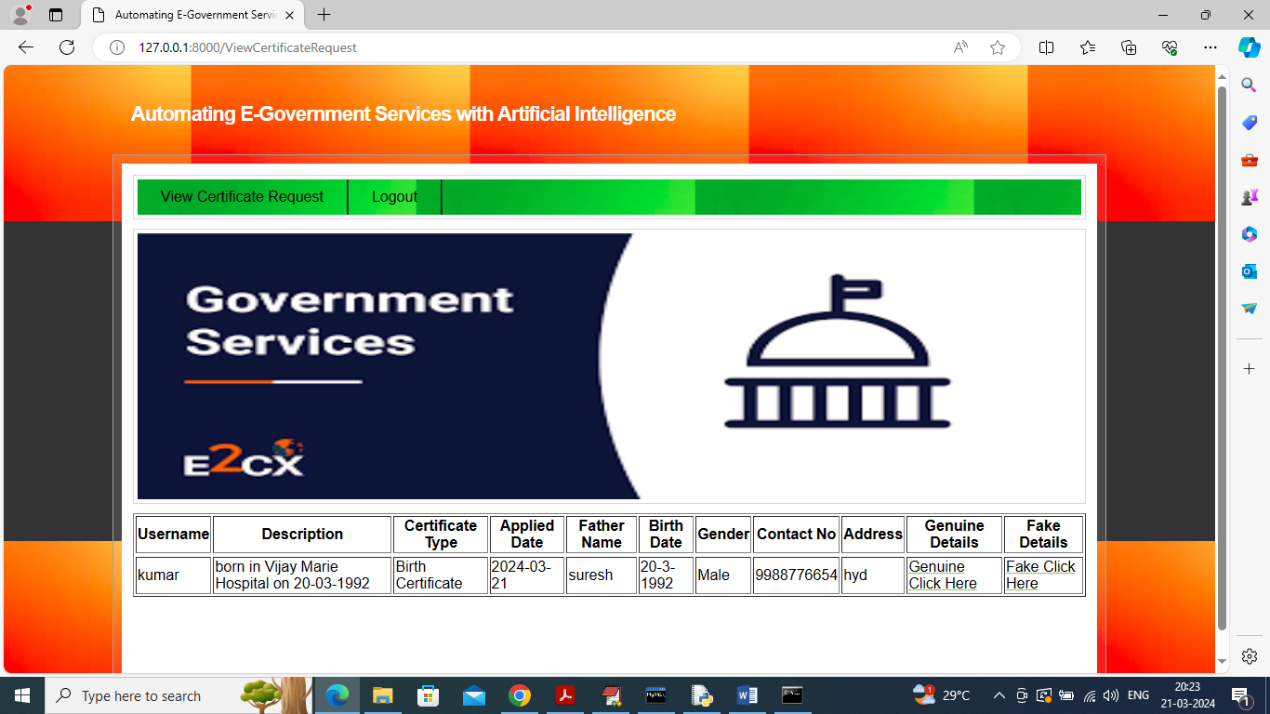

In above screen hospital will verify all details of user and then either click on ‘Genuine to approve request or fake to cancel request. After approval will get below page

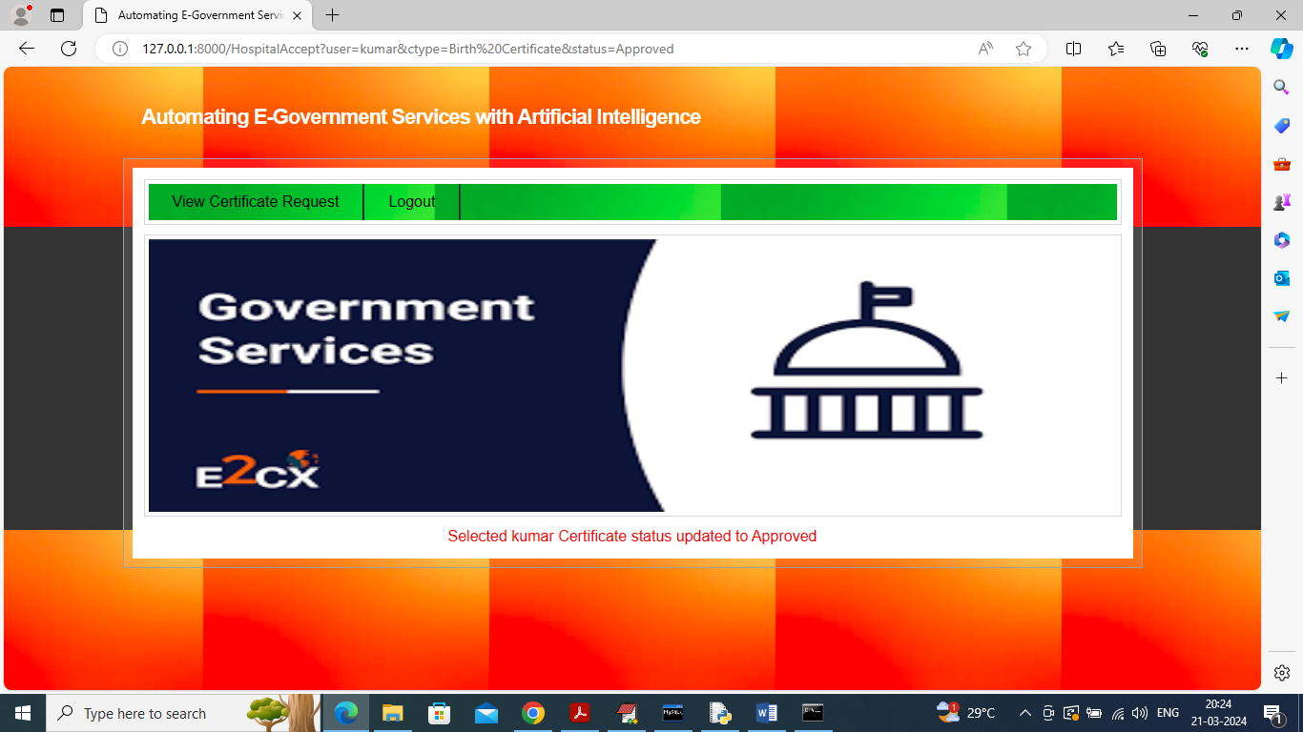

In above screen can see certificate request approved and now logout and login as ‘Revenue department’ to approve or reject income or community certificate request.

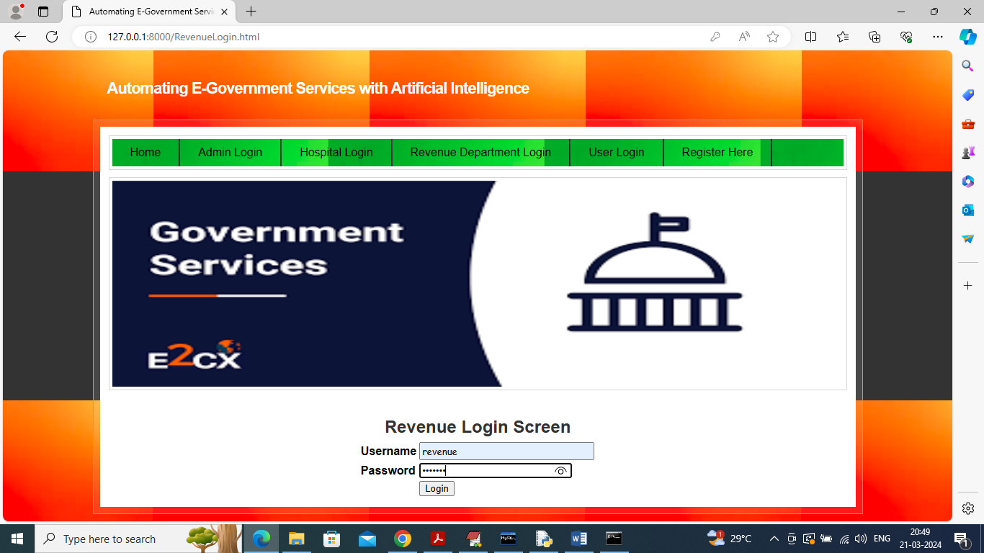

In above screen revenue department is login and after login will get below page

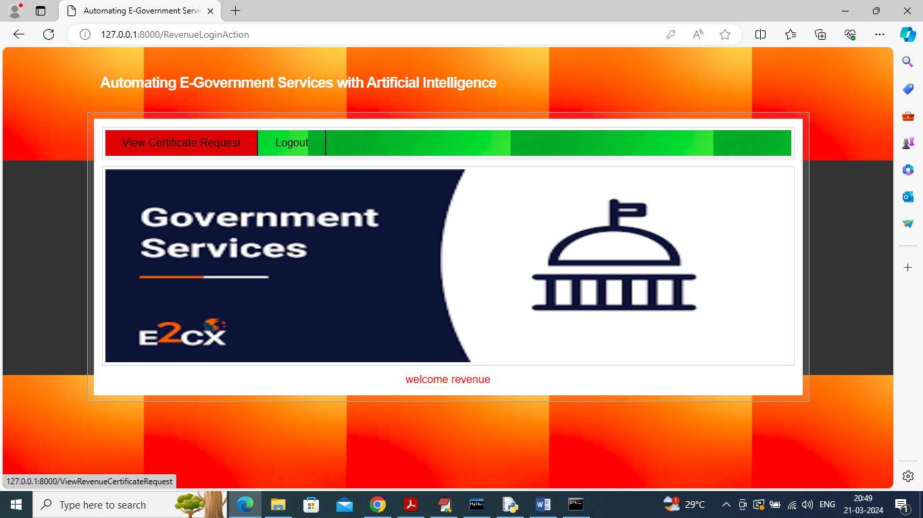

In above screen click on “View Certificate Request’ link to view list of income and community certificate request and get below page

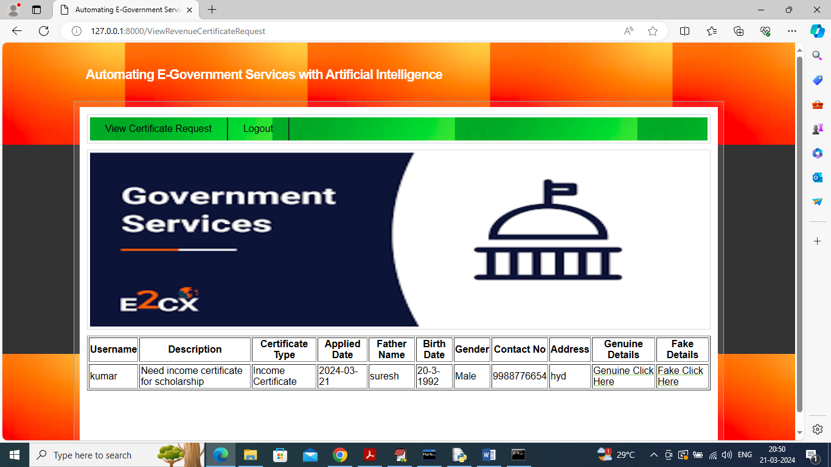

In above screen department will verify all details and then based on details either click on ‘Genuine or Fake’ link to approve or reject request and after approval will get below page

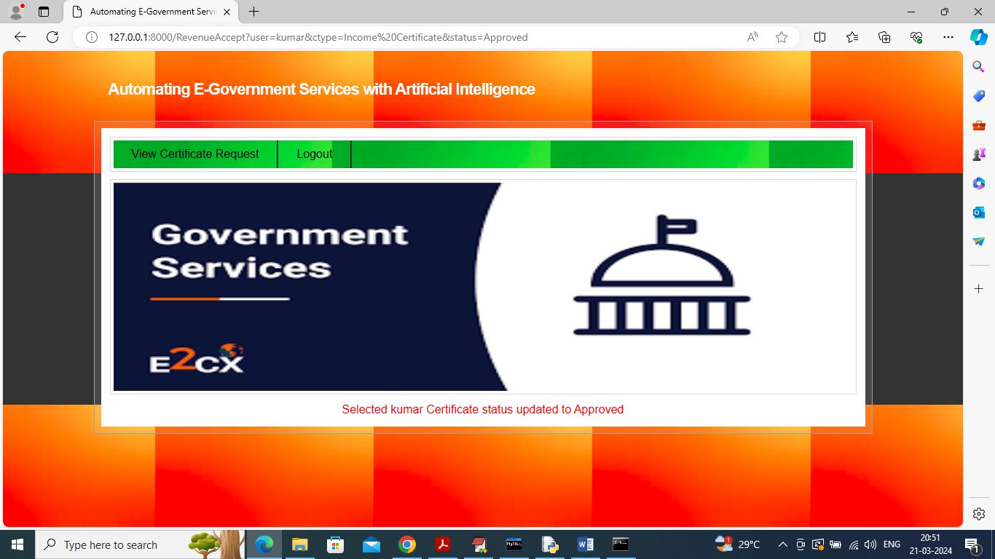

In above screen can see status is updated as approved and now logout and login as admin to issue certificate for approved users

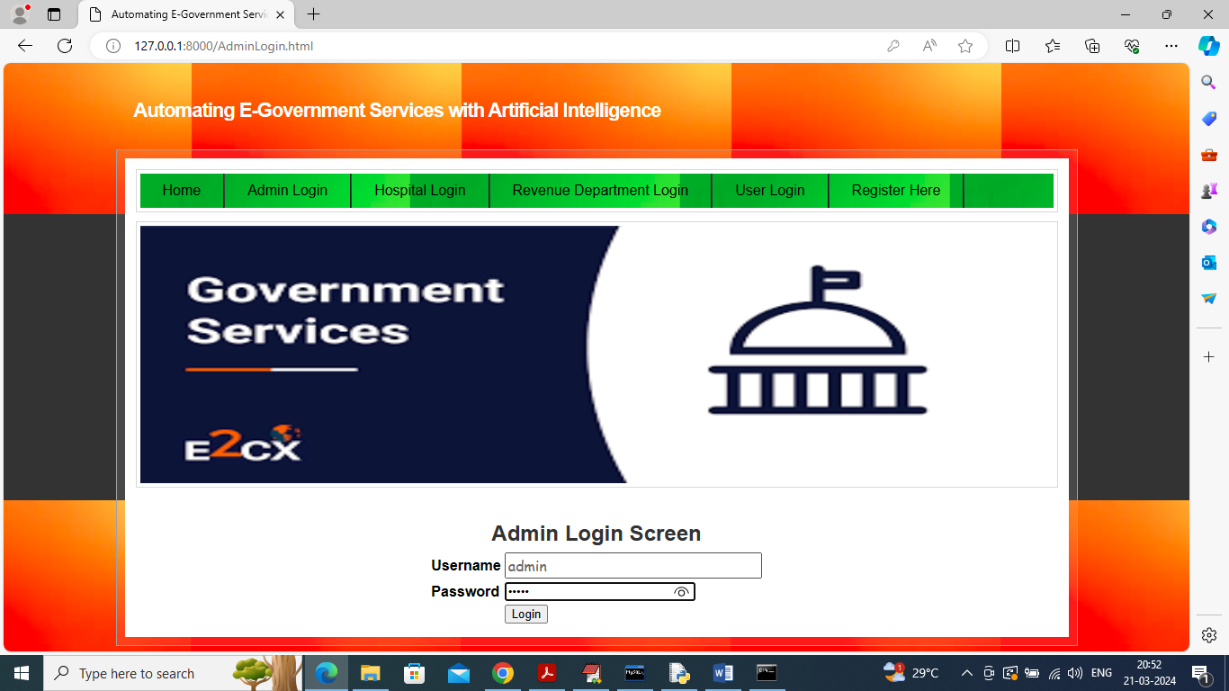

In above screen admin is login and after login will get below page

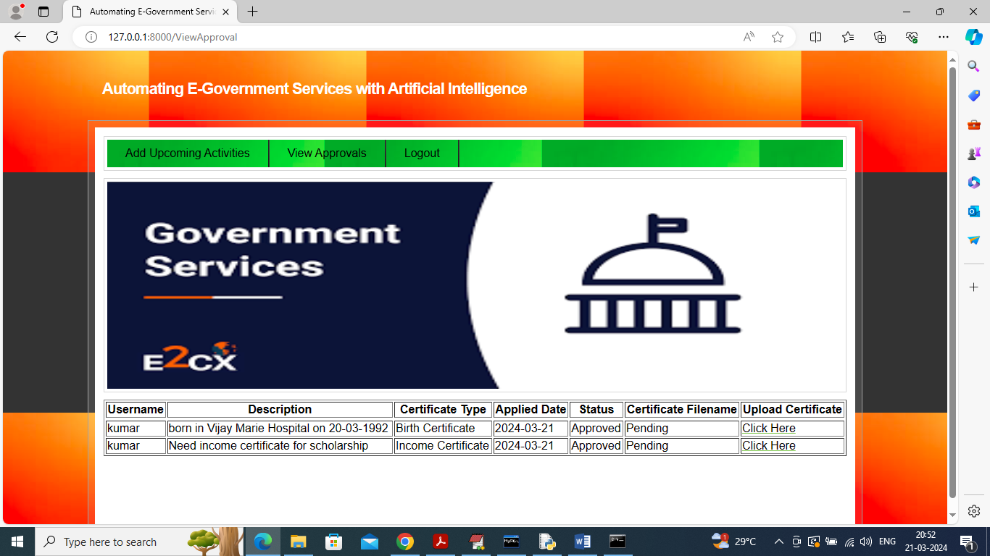

In above screen admin can view list of approved certificates from hospital and revenue department and can click on ‘Click Here’ link to issue certificate

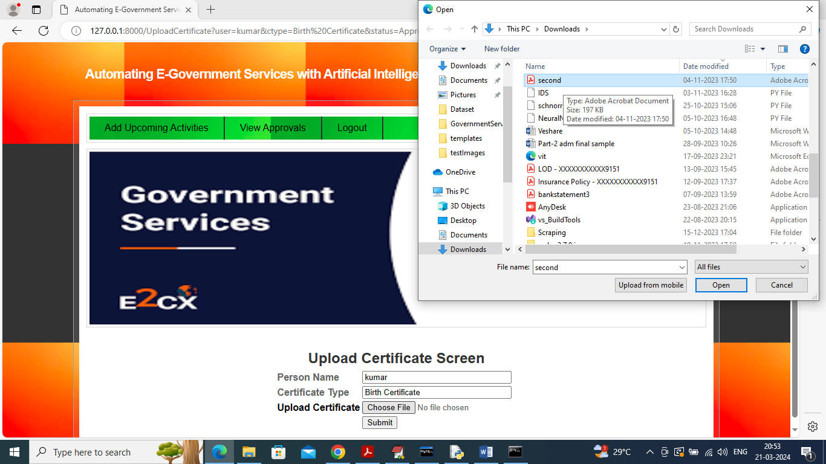

In above screen admin will upload issue certificate and then click on ‘Submit’ button to send certificate to user and get below page

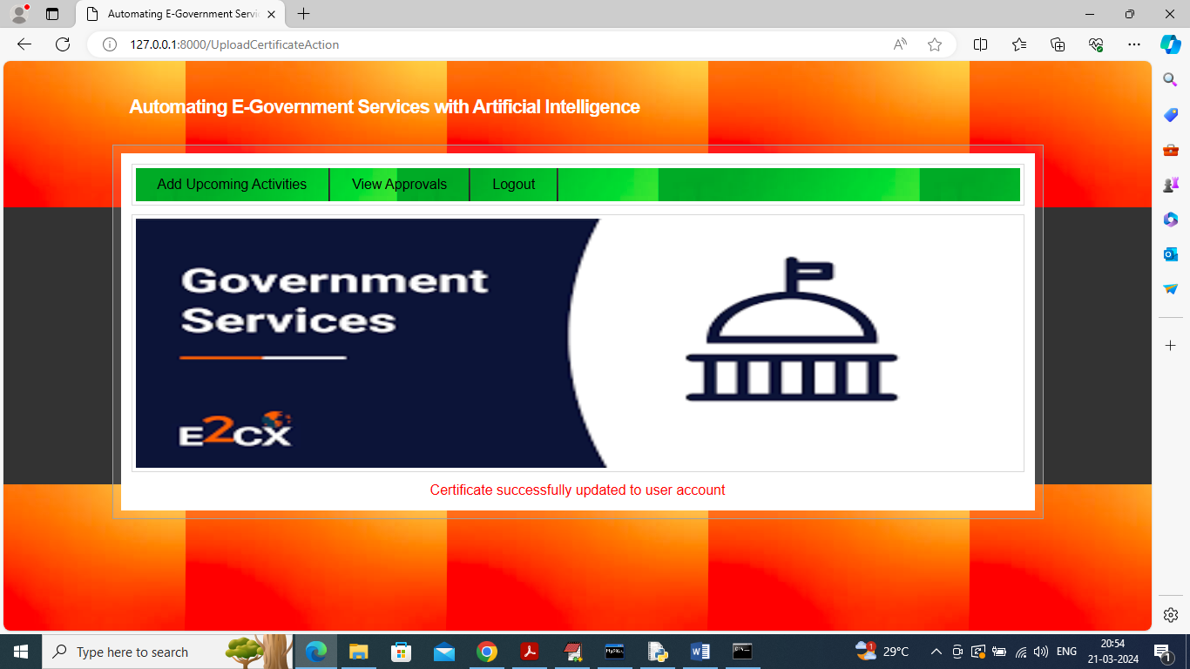

In above screen can see certificate updated to user account which user can download by entering OTP received in email. Now admin can click on ‘Add Upcoming Activities’ link to get below page

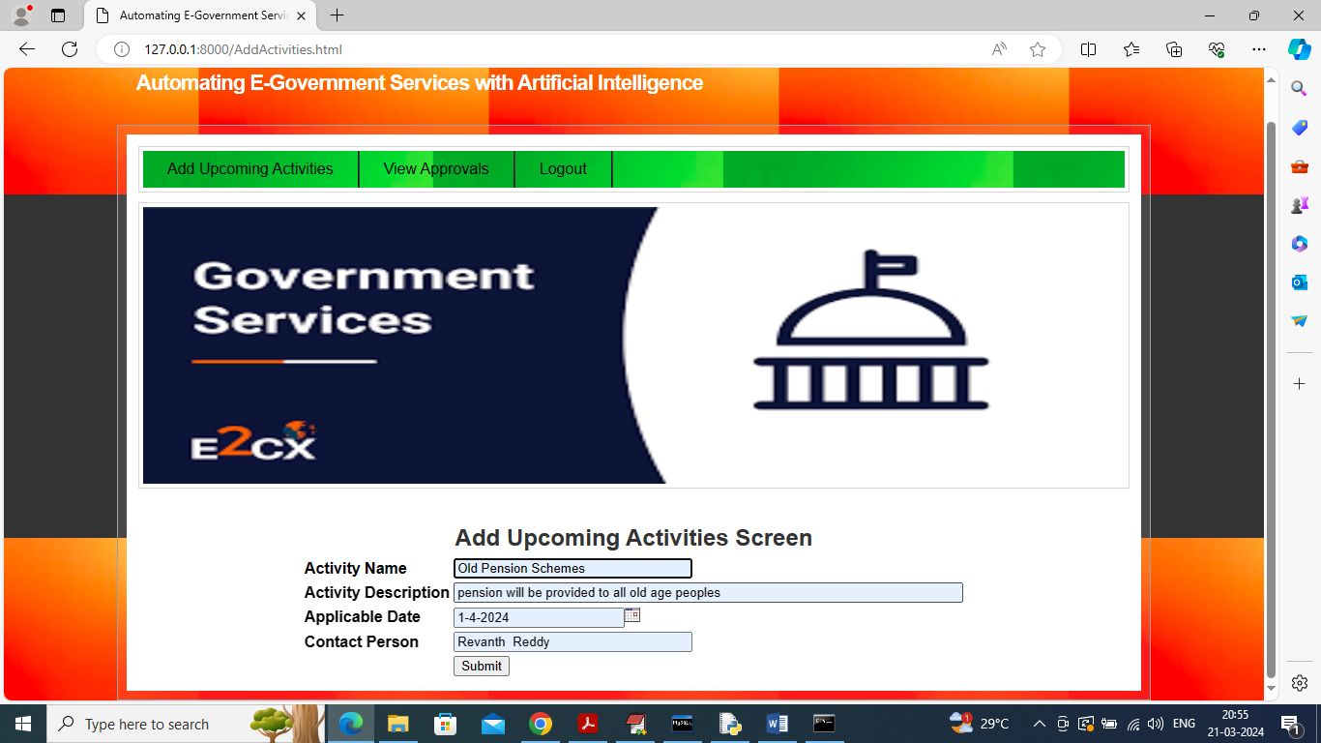

In above screen admin will add all upcoming schemes or events which user can view and now press button to save event and get below page

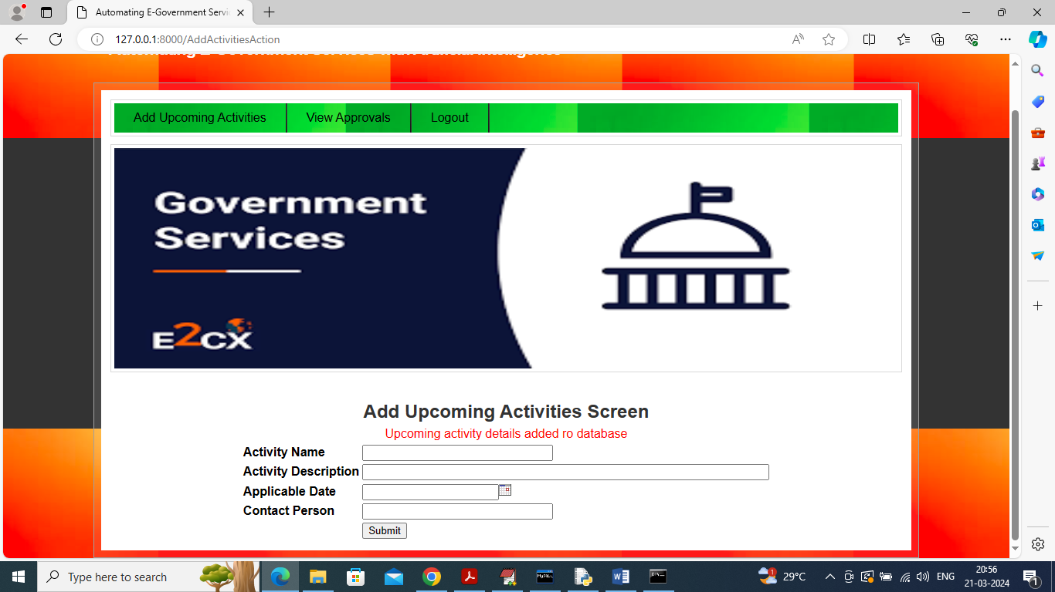

In above screen can see scheme or event details added and now logout and login as user to view and download certificate

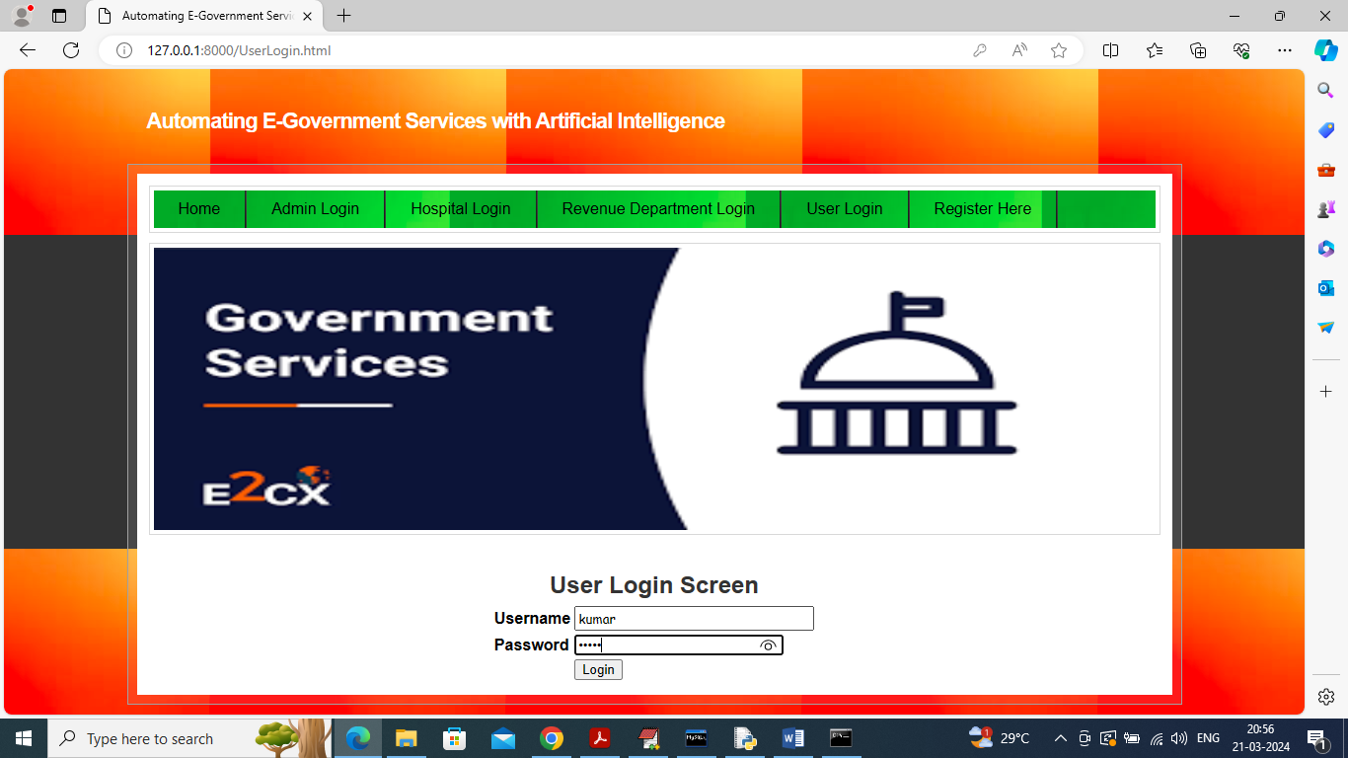

In above screen user is login and after login will get below page

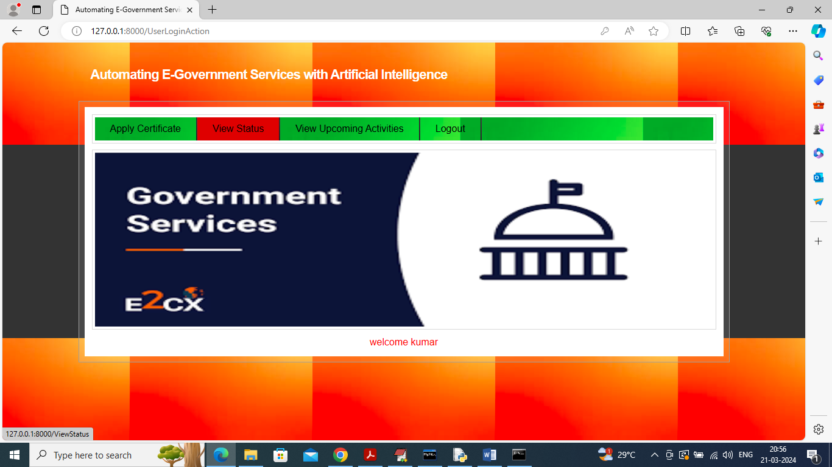

In above screen click on ‘View Status’ link to view status of all submitted certificate details and get below page

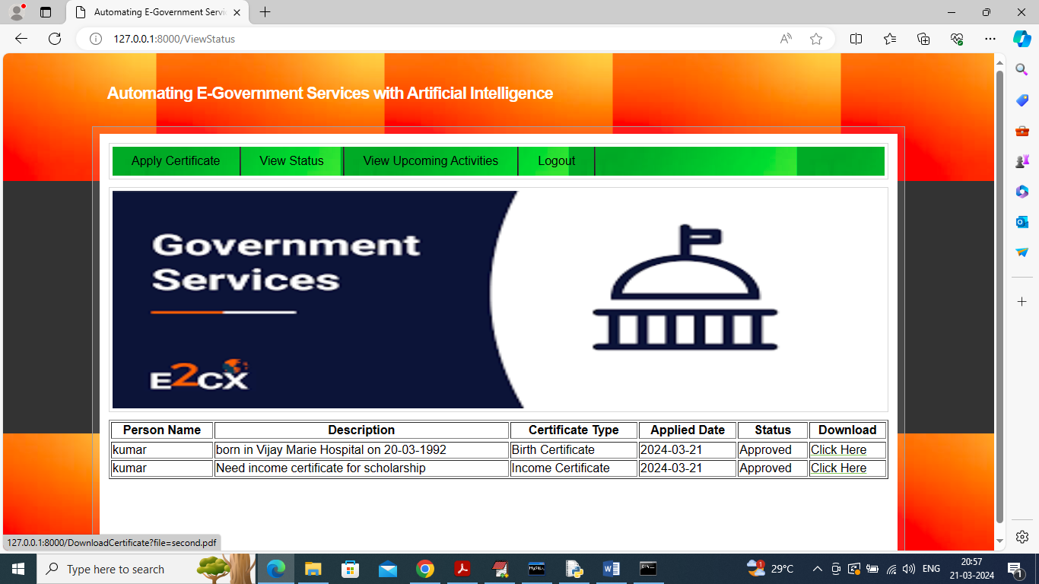

In above screen user can click on ‘Click Here’ link to receive OTP to email and after entering OTP can download certificate like below screen

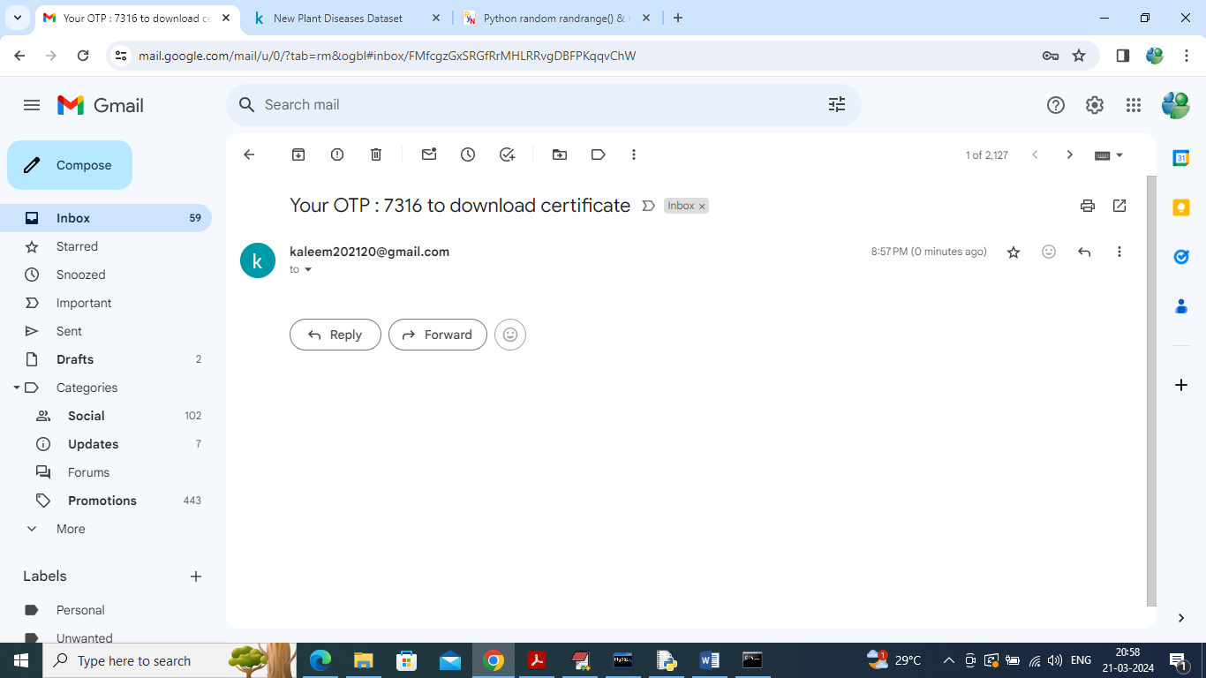

In above screen OTP received in email and now enter above OTP to download certificate

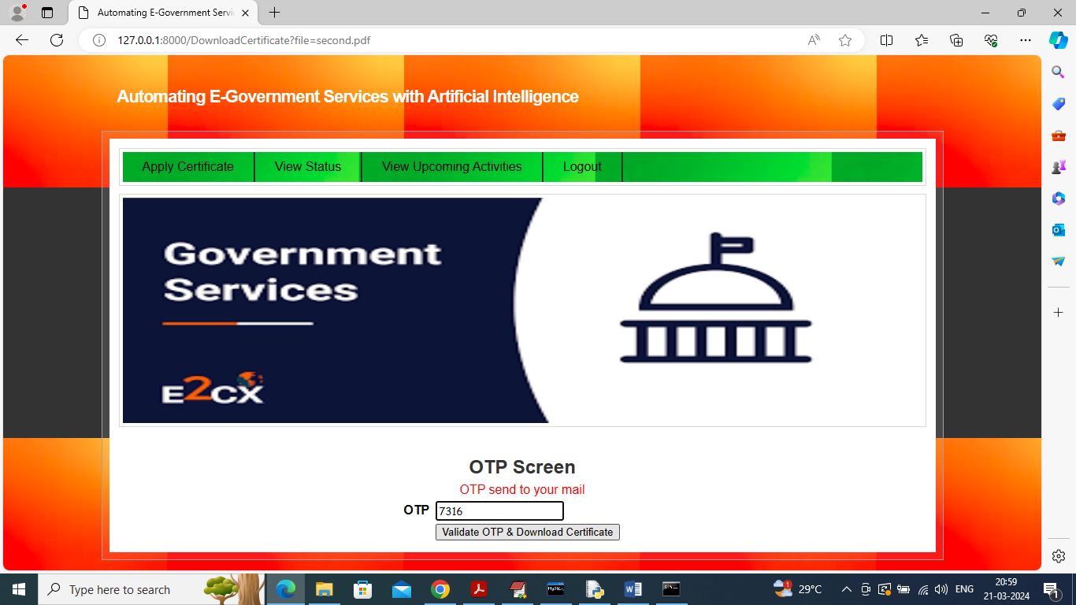

In above screen enter OTP to get below download page

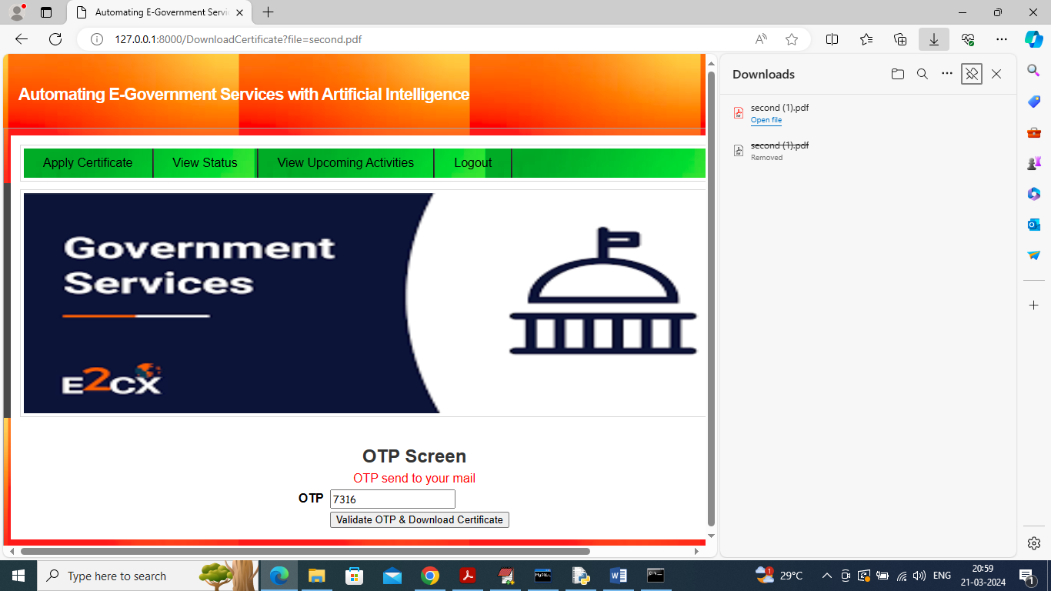

In above screen in right side panel can see certificate is downloaded. Similarly by following above screens you can apply for certificate and now click on ‘View Upcoming Activities’ link to view list of all upcoming activities

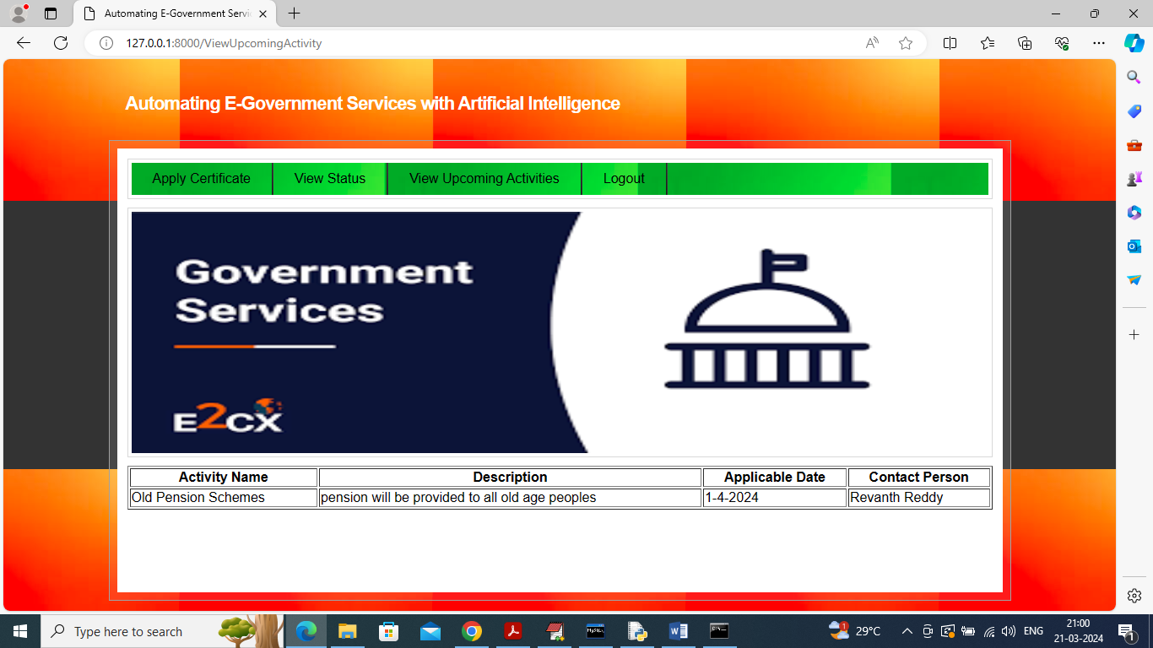

In above screen user can view list of all upcoming events or activities.